Workshop 2

# Login-Registration

### **Login Screen :**

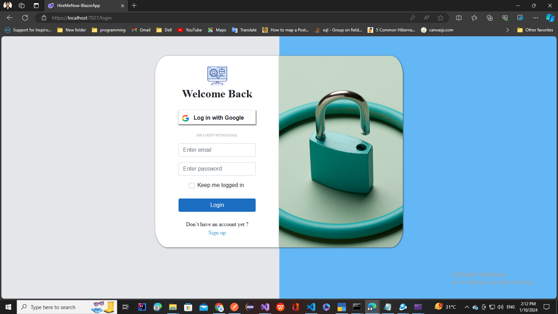

### **Registration Screen :**

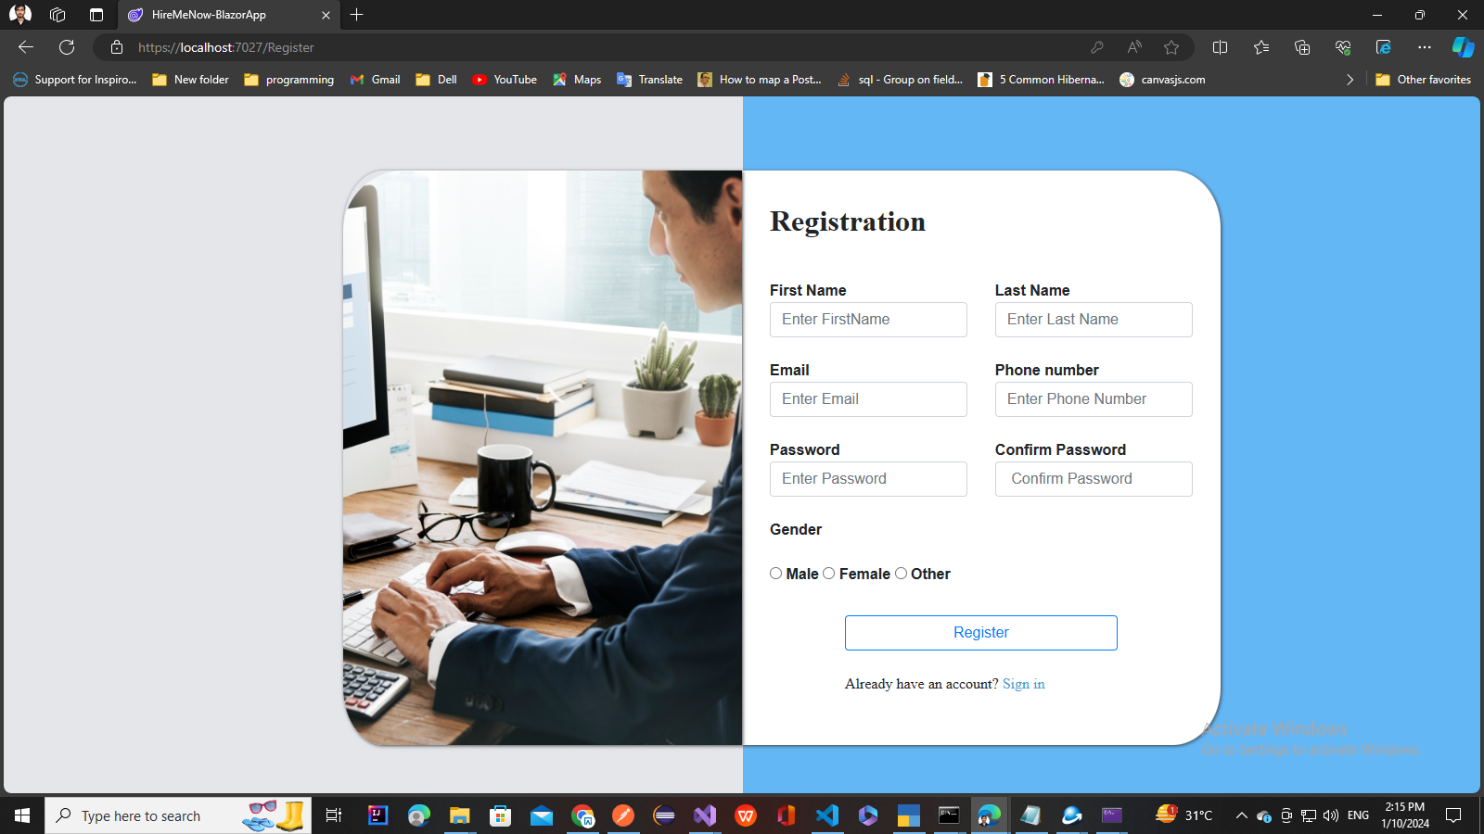

### **Overview:**

Blazor is a framework for building interactive web applications using C# and .NET. In this workshop, we'll explore the fundamentals of Blazor by creating pages for a job portal application.

### **Workshop Goals:**

* Understand the basics of Blazor and its components
* Create a job list page using Blazor components
* Implement functionality for login and register

### **Prerequisites:**

* Basic knowledge of C# and .NET Core
* Familiarity with HTML, CSS, Bootstrap and JavaScript

### **Workshop Agenda:**

#### Part 1: Introduction to Blazor

* What is Blazor?
* Blazor hosting models (Server-side and WebAssembly)
* Benefits of using Blazor for web development

#### Part 2: Setting Up the Project

* Clone the Application and open in Visual studio
* Go through the Project structure overview

#### Part 3: Go through Components and Check How Dependency Injection works

#### Login component

* Register Component

#### Part 4: Go through layout page (LoginLayout) and Its Implementation

#### Part 5: Implement Login register functionality

### **Resources:**

* Visual Studio or Visual Studio Code
* .NET Core SDK

### **Conclusion:**

Blazor offers a powerful way to build interactive web applications using .NET. By creating an admin job list page, you've explored the basics of Blazor components, data binding, and functionality implementation. Continue exploring Blazor to unleash its full potential in web development.